Survey Question

Prototype Survey Questions

**Open:** First Name:

**Open:** Last Name:

**Open:** Middle Name:

**Open:** Age:

**Choice:** Gender: Male/ Female/ Prefer not to say

**Open:** Email:

**Choice:** Have you used any website program advisory tool before?

Yes/ No

**Open:** If yes, please provide the details of your experiences with previous website.

**Choice:** On the scale of 1 to 5, is the website easy to use for you?

1. Very Easy/ 2. Easy/ 3. Neutral/ 4. Difficult/ 5. Very Difficult

**Choice:** On the scale of 1 to 5, how satisfied are you with your experience using the website?

1. Very Satisfied/ 2. Satisfied/ 3. Neutral/ 4. Dissatisfied/ 5. Very Dissatisfied

**Open:** Would you mind sharing any feedback and suggestions regarding your experience with the website?

**Choice:** If the website is launched, would you recommend to others?

Yes/ No

**Choice:** May we recontact whether you can assist in improving our website?

Yes/ No

Theme Survey Question

**Choice:** We are in the process of designing our website’s user interface, and we value your opinion. Please help us choose the most appealing theme design. Pictures are shown below.

Option 1/ Option 2/ Option 3/ Option 4/ Option 5

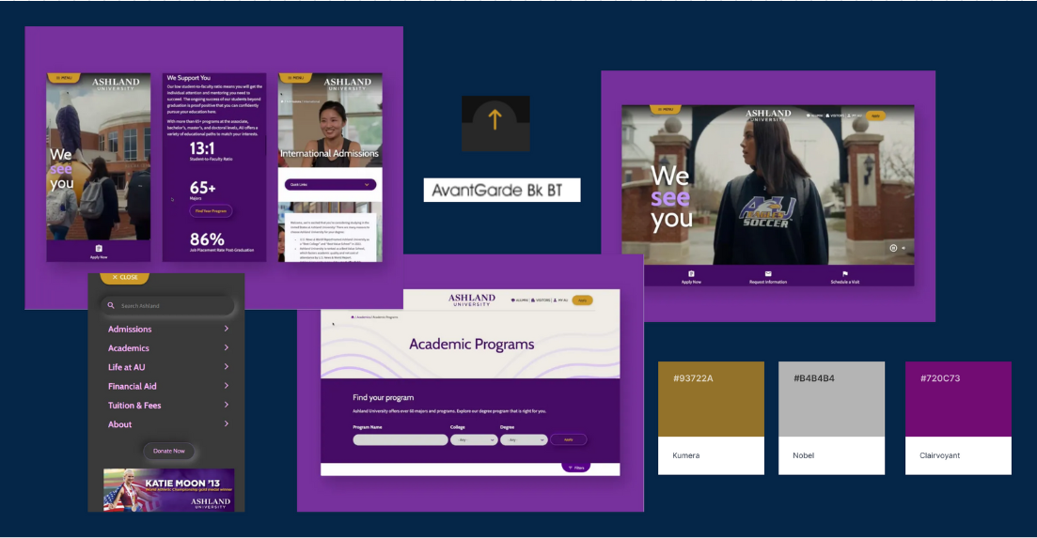

Option 1

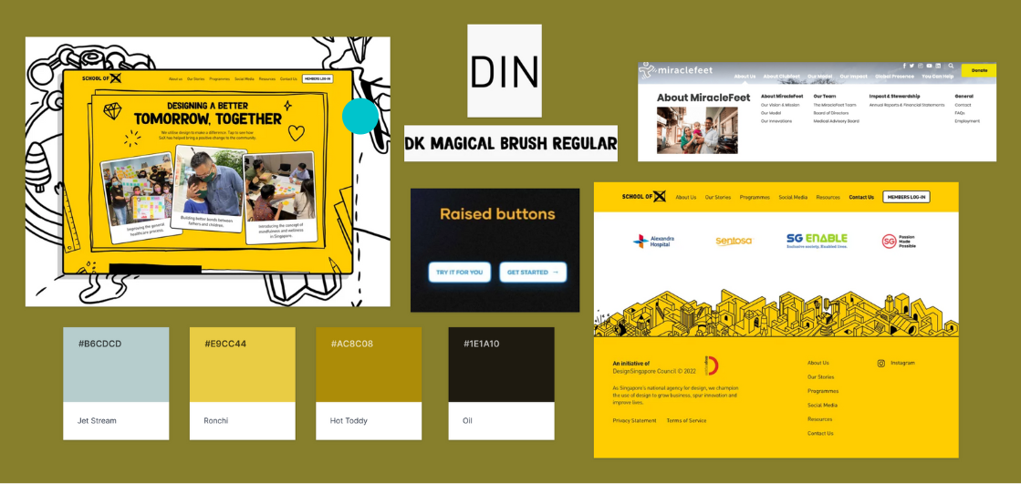

Option 2

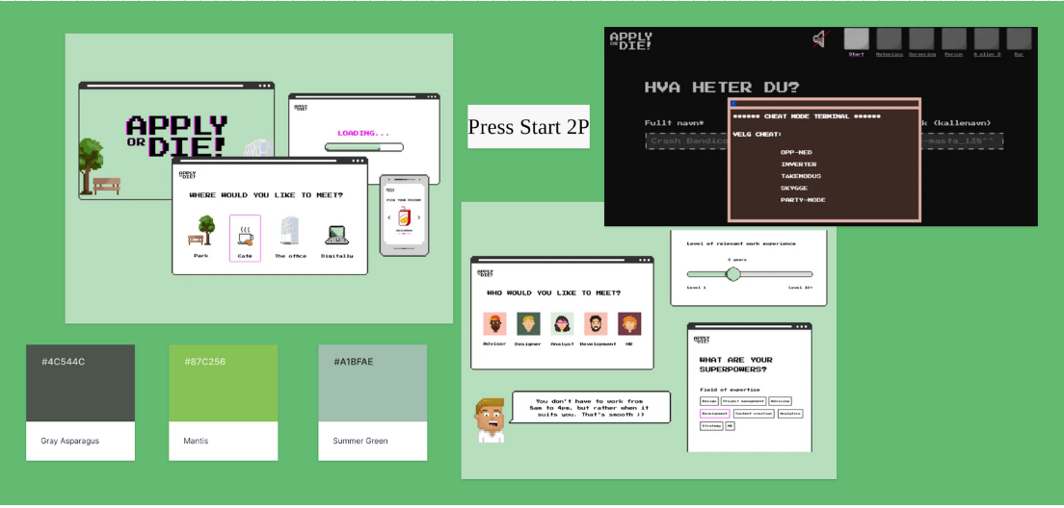

Option 3

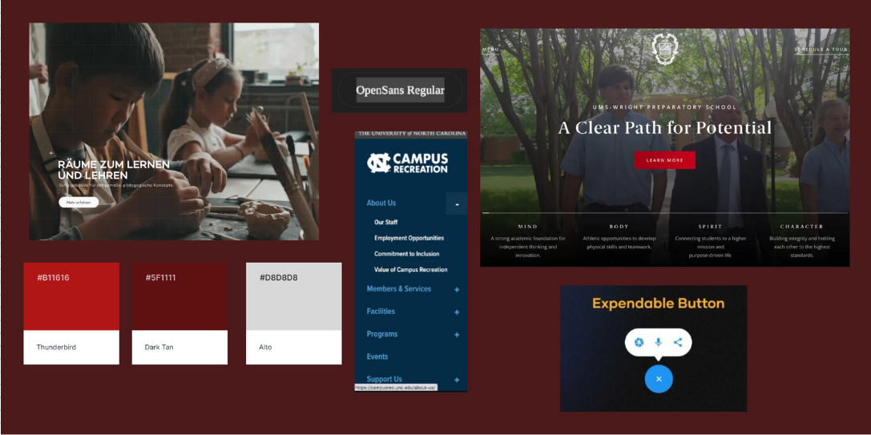

Option 4

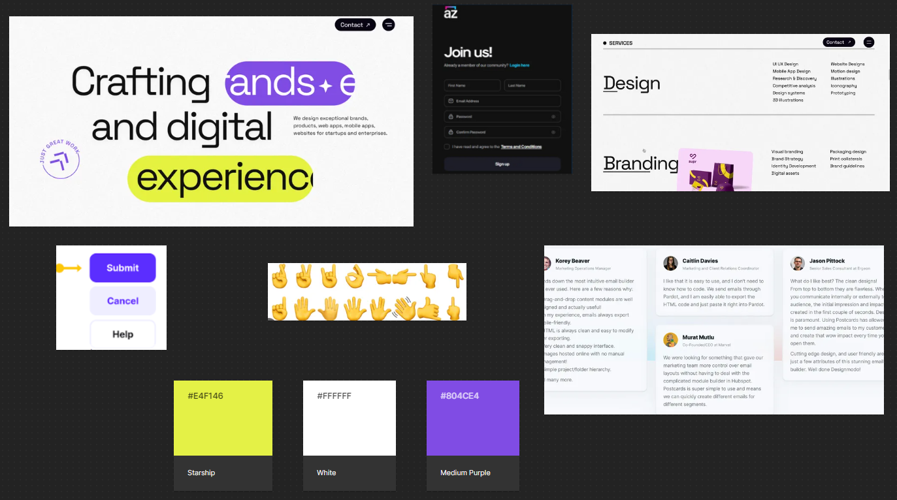

Option 5

**Open:** Based on the 5 theme designs you chose in the previous question, could you please explain why you found it appealing or why it stands out to you?